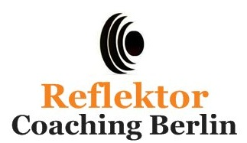
Anmeldung
Reflektor Coaching Berlin
Elfriede-Kuhr-Straße 44
12355 Berlin
oder per E-Mail: reflektor.coaching.berlin@gmail.com

Seminar / Workshop
___________________________________________________________________________
Seminar / Workshop-Nr. _____________ Seminar / Workshop-Datum __________________
Ersatztermin _________________________________________________________________
Rechnungsanschrift
Name / Firma
___________________________________________________________________________
Ansprechpartner*in ___________________________________________________________
Straße, Haus-Nr. ______________________________________________________________
PLZ ______________ Ort _______________________________________________________
Telefon _____________________ E-Mail __________________________________________
Personalien
⃝ W ⃝ X ⃝ M zutreffendes bitte ankreuzen
Titel _________________
Vorname ______________________ Nachname ____________________________________
Funktion ____________________________________________________________________
Telefon _____________________ E-Mail __________________________________________
Ort, Datum _______________________ Unterschrift _______________________________

